**Insert data to code on Watson**

**Instructions:**

1. Access Watson Studio.
2. Follow the prompts to generate the code based on your requirements.

Here are the steps to be followed:

1.  Upload your data file in CSV format or any other compatible format to the data pane.

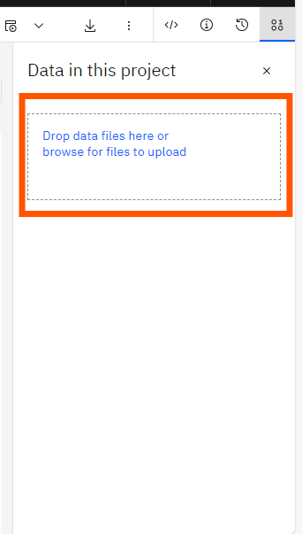

2. Once you have uploaded the data, tap on the **code (</>) icon**, from the left side of the data pane. and tap on the button "**select data from project"**.

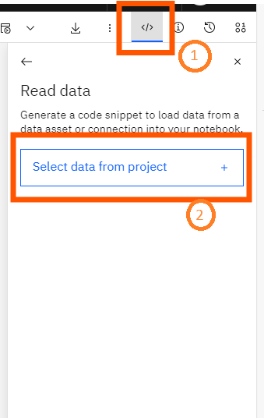

3. Click on “**Data Assets**,” then, select the uploaded data, and tap on “**Select.**”

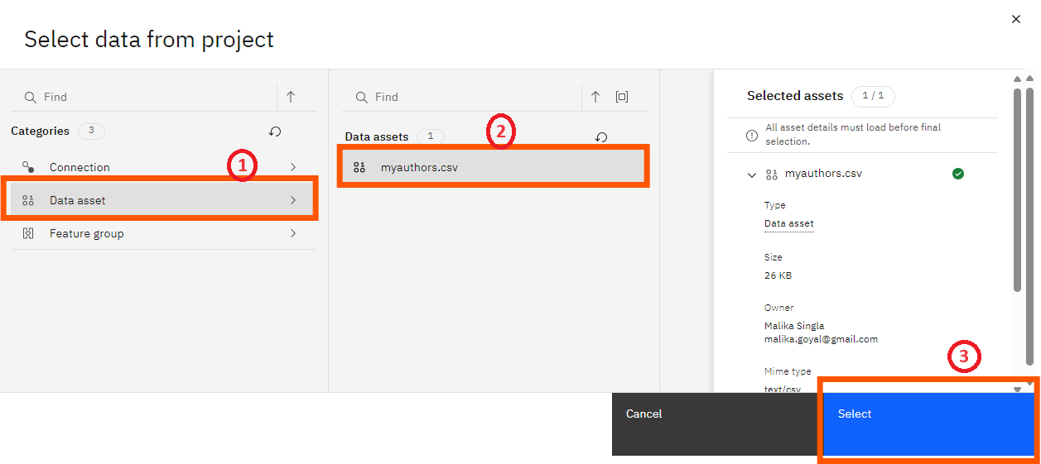

4. Click on "**insert code to cell**" button to insert the code.

